

Rapid Palatal Expansion (RPE) Instructions

The palatal expander “expands” (or widens) your upper jaw by putting gentle pressure on your upper molars each time an adjustment is made. We will instruct you about when and how to adjust your expander. When you achieve the desired expansion, you will wear the appliance for several months to solidify the expansion and to prevent regression. Call our office at 970-328-1075 if you have any issues.

What To Expect:

* A temporary lisp and/ or change in speech- usually takes about 1 week to adjust
* Excess saliva for a few hours
* Difficulties swallowing for a few hours
* You may develop a slight headache
* Some pressure in the back molars, on the roof of the mouth, and nose area might be felt during activation
* Space opening between front teeth is the indication that the expansion is working. Your teeth will shift later to fill the gap.
* Your bite may feel off

How To Care For Your Expander:

* Rinse/ swish with water or Waterpik to flush out food between the expander and the roof of your mouth
* Brush with a toothbrush around the entire expander (including all metal parts and screw)
* Maintain soft diet for the first few days
* Avoid any sticky and hard foods that can dislodge the expander

**Frequency: ________ turns per week After ______ turns, please take 2 pictures and email to** [**info@eagleortho.com**](mailto:info@eafleortho.com) **After a total ______turns, please do not turn anymore and call us at 970.328.1075 to schedule an appointment.**

**This is what your 2 photos should look like:**

**Picture #1**

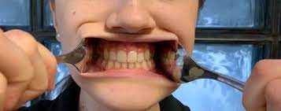

**PIcture #2**

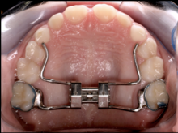

**Tips for taking a good photos of your RPE:**

1. **Good lighting or use the flash**
2. **Get close!**
3. **You can use spoons to retract the lips**

