

**PHASE 2 CLEAR RETAINERS**

Congratulations on your new smile!

**Why were you given a retainer?** When the braces are removed, the bone around the teeth is soft. Immature bone is not strong enough to hold the teeth in their new position. Retainers hold the teeth in their new position and minimize future tooth movement.

**When should you use your retainers?**

* You have been given clear retainers to start wearing for 12 hours a night.
* You will continue to wear your retainers as long as you want to keep your teeth straight meaning: **wear them** **for the rest of your life**!
* When you are not using your retainers, please store them in the case.
* Do NOT wrap them in a napkin because they can be thrown away or damaged.
* **Keep them away from your pets**.
* Since the retainers are made of plastic, please use two hands to put them in and take them out. We will see you back in 8 months for a retainer check appointment unless you are having any issues. Remember to bring you retainers to that appointment!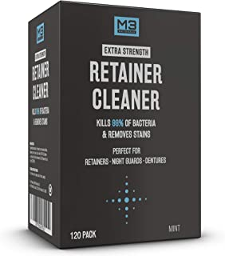

**How do you clean the retainers?**

Retainers should be cleaned daily with antibacterial soap and water. You can also use a retainer/denture cleaner. We recommend using **M3 Naturals Extra Strength**

**Retainer Cleaner.** You can purchase it at the office or off of Amazon. Do not use toothpaste because it will scratch them. DO NOT USE hot water.

**What should you do if your retainers are lost, broken, or loose?** If you feel like your retainer is broken, or not fitting properly, go to the next set. If they feel loose, call our office so that we can see if they can be tightened. If you need new ones, please call our office for replacements. A new set of retainers will be at an additional charge. If you are no longer in town, we can mail them to you.

**What happens if you do not wear your retainer and your teeth move?** If you do not wear your retainers and your teeth move, you may need to have braces/Invisalign again or a new retainer. You will be charged an additional fee.

**Retainer Insurance:** You may lose or break your retainer several times over your lifetime.Our Retainer Insurance Program provides you with 5 years worth of replacement retainers guaranteed to keep you smiling! For only $680 you can enroll in our 5-year Retainer Insurance Program, in which you will be charged a small $30 copay per arch to replace your retainers as needed (a $300 value each time!)

Patient Name: ______________________________ Patient Signature:___________________________

Legal Guardian Signature:___________________________________ Date:________________________